1. require your own personal access token

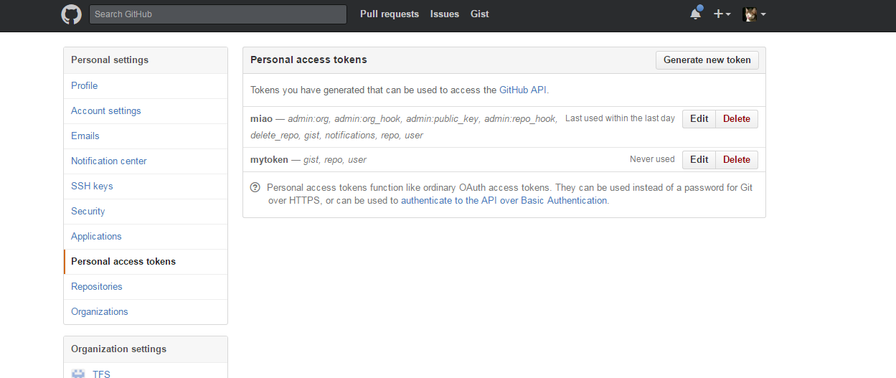

Click , on the right side.

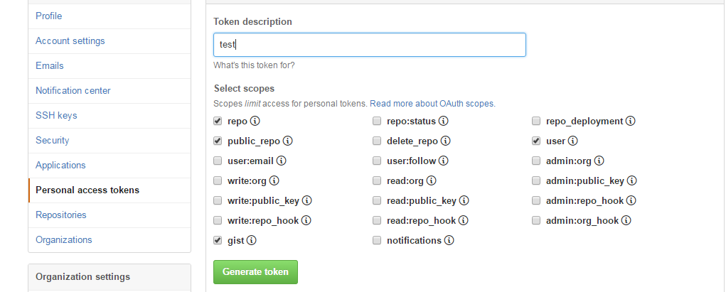

Fill the description what you want

click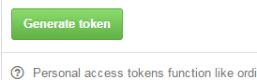

then copy the new token

1. login github with token

click 

when you get this page

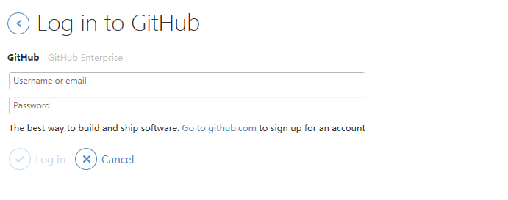

Click  GitHub Enterprise

Use the token take place the password

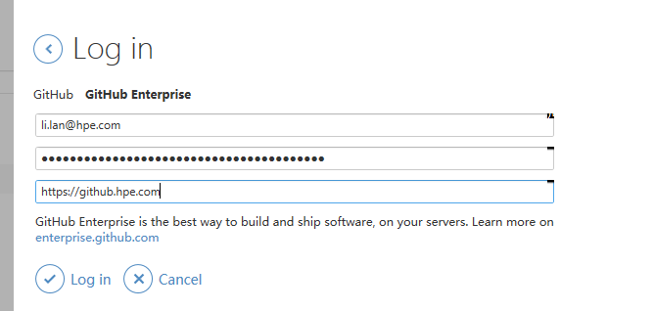

Then you will get it